# 2024 Campaign Email Templates

# 

# How to Use Templates

# Keep your United Way campaign top of mind for your employees! Consider using these suggested emails to craft your own communication plan.

* Links to suggested videos and tools are included, but you may want to remove if you have shared these videos/tools in a different format (such as at a kickoff).

# Pre-Kickoff/Welcome Message

Subject Line: Join Us in Making a Difference: United Way Campaign Coming Soon!

Dear [First Name],

We are thrilled to announce the upcoming United Way Campaign here at [Company Name]! United Way of Bemidji Area unites our community to tackle our most pressing challenges, and your support is crucial in making this happen.

This year's theme is Give Where You Live. By participating in this campaign, you are directly impacting the lives of our neighbors, friends, and colleagues. Through strategic partnerships and collaborative efforts, United Way brings the many voices of the Bemidji Area together to find common ground and develop strategic plans for change. Your commitment to this year’s campaign will provide our community with the programs and services needed to live healthy lives and thrive.

Please take a moment to review the [United Way Impact Report](https://www.unitedwaybemidji.org/sites/unitedwaybemidji/files/2024%20United%20Way%20Impact%20Report.pdf) and mark your calendars for the start of our United Way charitable giving campaign on [Campaign Start Date]. Additionally, attached is the [2024 Event and Program calendar](https://www.unitedwaybemidji.org/sites/unitedwaybemidji/files/United%20Way%20Event%20%26%20Program%20Calendar.pdf) – we hope you’ll join us for these inspiring and impactful events throughout the year.

Together, we can do more. Let’s Give Where We Live!

P.S. Follow United Way of Bemidji Area on [[[**Facebook**](https://www.facebook.com/unitedwaydaneco/)](https://www.facebook.com/UnitedWayBemidji)](https://www.facebook.com/UnitedWayBemidji), [[[**Instagram**](https://www.instagram.com/unitedwaydaneco/)](https://www.instagram.com/unitedwayofbemidji/?hl=en)](https://www.instagram.com/unitedwayofbemidji/), and [**Email Newsletters**](https://visitor.constantcontact.com/manage/optin?v=001S2avIeJoU08eyhfDMCqUXM4vuAYUnREam2bm7CpUjVDil2_BH1sSgPH75QJHOtcgt9XIK_2AAuskP00lJNxRvtS4K4m1mTxw) to stay up-to-date!

# Kickoff Email

Subject Line: United Way Campaign Kick-Off!

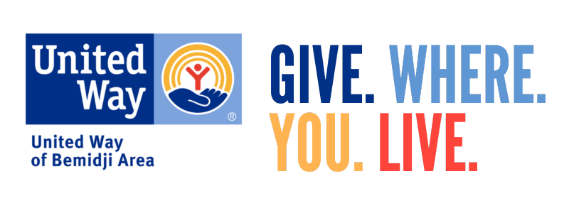

Dear [First Name],

Today marks the beginning of [Company Name]’s 2024 United Way Campaign! We’re inviting each and every employee to join forces and help make a difference in our community.

Together, we have the power to create lasting change in our community. By embracing the theme Give Where You Live, your donation will directly support our neighbors in need. Please consider contributing today. You can make your gift through [provide instructions for online donations or paper pledge forms].

Don’t forget, our goal is to [raise $$$ *OR reach %%% participation] by the end of our campaign on [DATE].

Feel free to reach out to me with any questions about your donation, or to seek out volunteer opportunities!

# Midterm Email

Subject Line: Every dollar makes a difference

[Salutation],

As our United Way Campaign is nearing the end, we want to make sure you have a chance to help address the Bemidji Area’s greatest needs. Even the smallest gift can add up to big wins for our community.

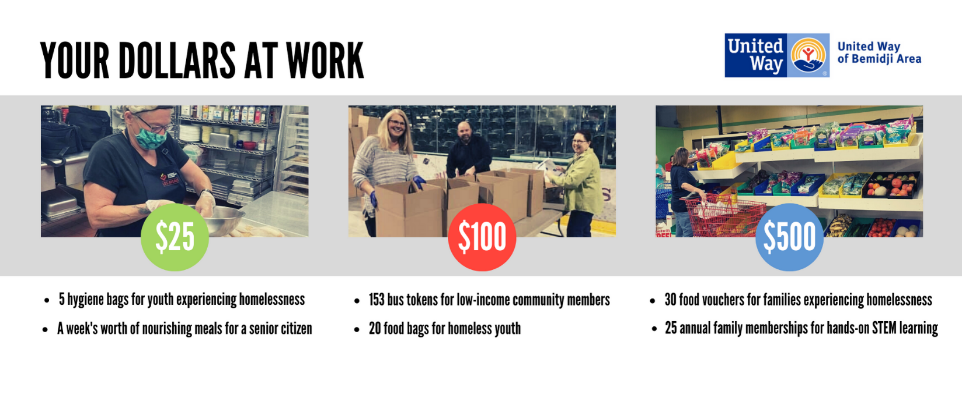

[Add how to make a gift, for example through online or paper pledge form]

Thank you.

[Closing],

P.S. Follow United Way of Bemidji Area on [[[**Facebook**](https://www.facebook.com/unitedwaydaneco/)](https://www.facebook.com/UnitedWayBemidji)](https://www.facebook.com/UnitedWayBemidji), [[[**Instagram**](https://www.instagram.com/unitedwaydaneco/)](https://www.instagram.com/unitedwayofbemidji/?hl=en)](https://www.instagram.com/unitedwayofbemidji/), and [**Email Newsletters**](https://visitor.constantcontact.com/manage/optin?v=001S2avIeJoU08eyhfDMCqUXM4vuAYUnREam2bm7CpUjVDil2_BH1sSgPH75QJHOtcgt9XIK_2AAuskP00lJNxRvtS4K4m1mTxw) for more opportunities to give, advocate, and volunteer!

# Last Chance Email

Subject Line: It’s never too late to Give Where You Live

[Salutation],

We are so proud of the progress we’ve made with our United Way campaign! A reminder that our United Way campaign is wrapping up on [XYZ date.]

**There is still a chance to support the United Way and their Partner Agencies who impact more than 60,000 people in our community each year!** Learn more about the United Way Partner Agencies [**here.**](https://www.unitedwaybemidji.org/partner-agencies)

***Did you know:***

- 99% of funds raised through the United Way stay local, creating real, positive change.

- The United Way runs internal programs to fill service gaps and reach more individuals in need, including: Backpack Buddies, Child Abuse Prevention, Coats for the Community, Holiday Gifts for Kids, Imagination Library, School Supplies Drive, Thanksgiving Meals, Volunteer Bemidji, and Wheels to Work.

- United Way supports their partner agencies beyond their annual funding. United Way provides help with capacity building, marketing, fundraising, volunteer connections, and strategic services to help local non-profits service more people.

[Add how to make a gift, for example through online or paper pledge form]

[Closing],